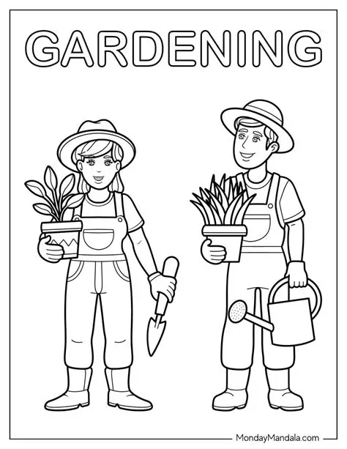
5 – 7 Poster 2026 Please print your name and age on the back

