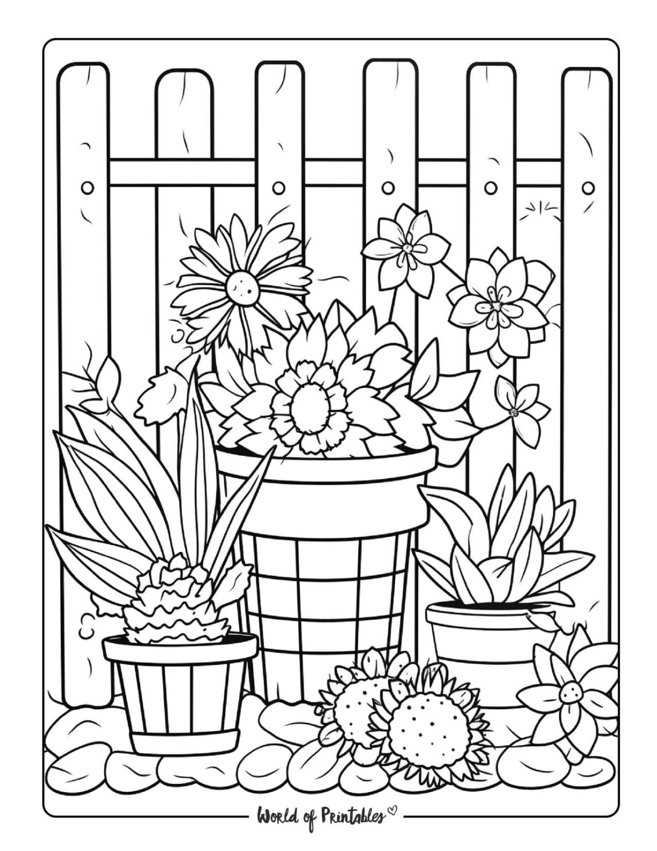
8 – 10 Poster 2026 Please print your name and age on the back

